**CANTERBRURY REPRESENTATIVE TEAM 1947-48**

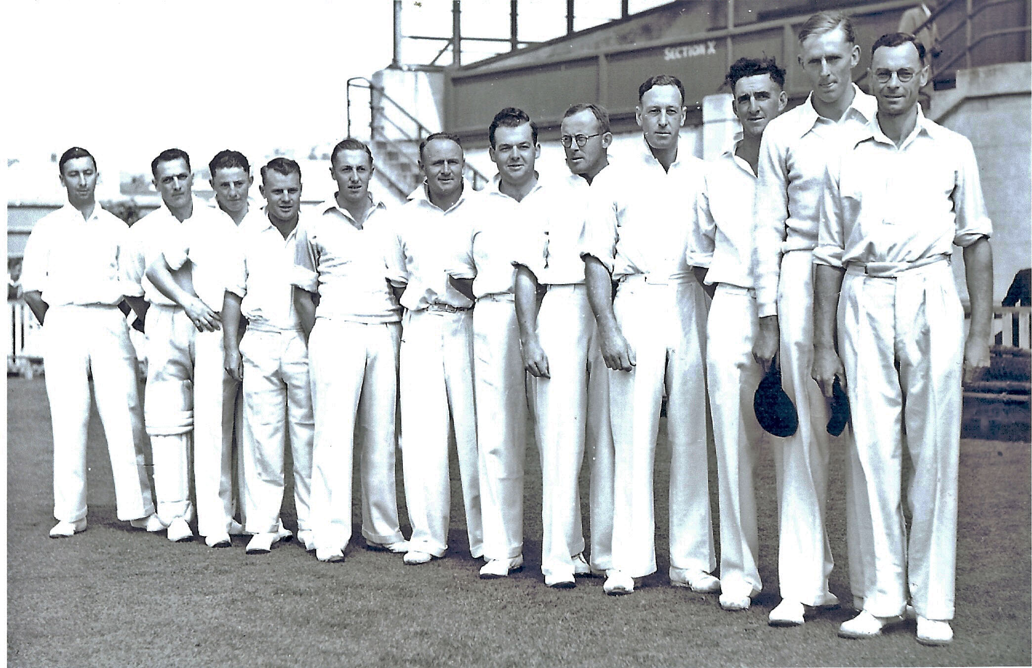

**From left to right: AEL Britton ORD Whitford Unknown FB Smith PAT Small TB Burtt JG Leggat**

**WMcD Anderson RH Scott PW O’Malley AR MacGibbon WA Hadlle (captain)**